# Capstone Project 1 – Data Story

## Top 10 grids

Top 10 are identified for each telecom activity. We observe that there isn’t significant difference in the volumes handled by the top 10 grids in each category. We will see that all these grids are in the center of the city with very high population density.

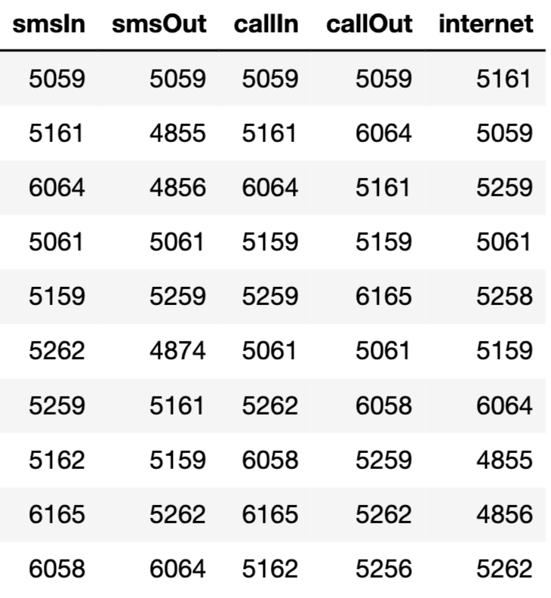

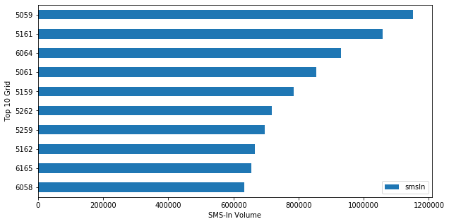

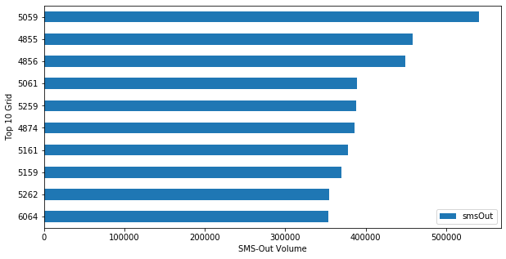

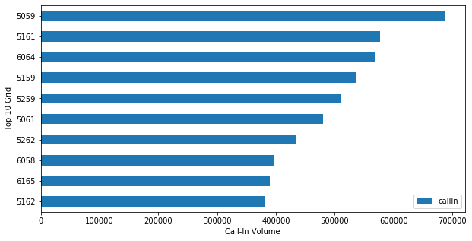

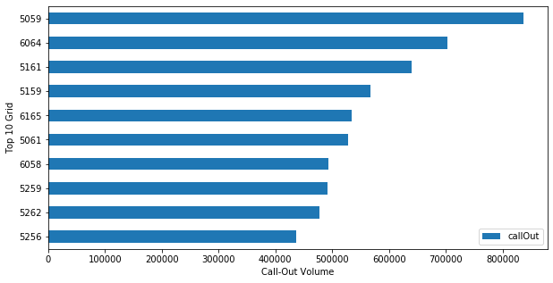

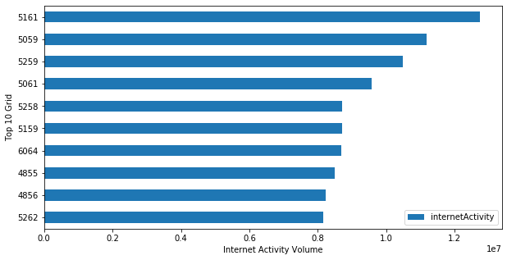

## Mapping Grids with real geographic locations

By mapping the grids in the geojson file on to [Milan’s population density map](https://www.arcgis.com/home/webmap/viewer.html?webmap=3cfda3efc00c4be1b60767b6e0999eb0), we are able to see that the top 5 Grids have high population density .

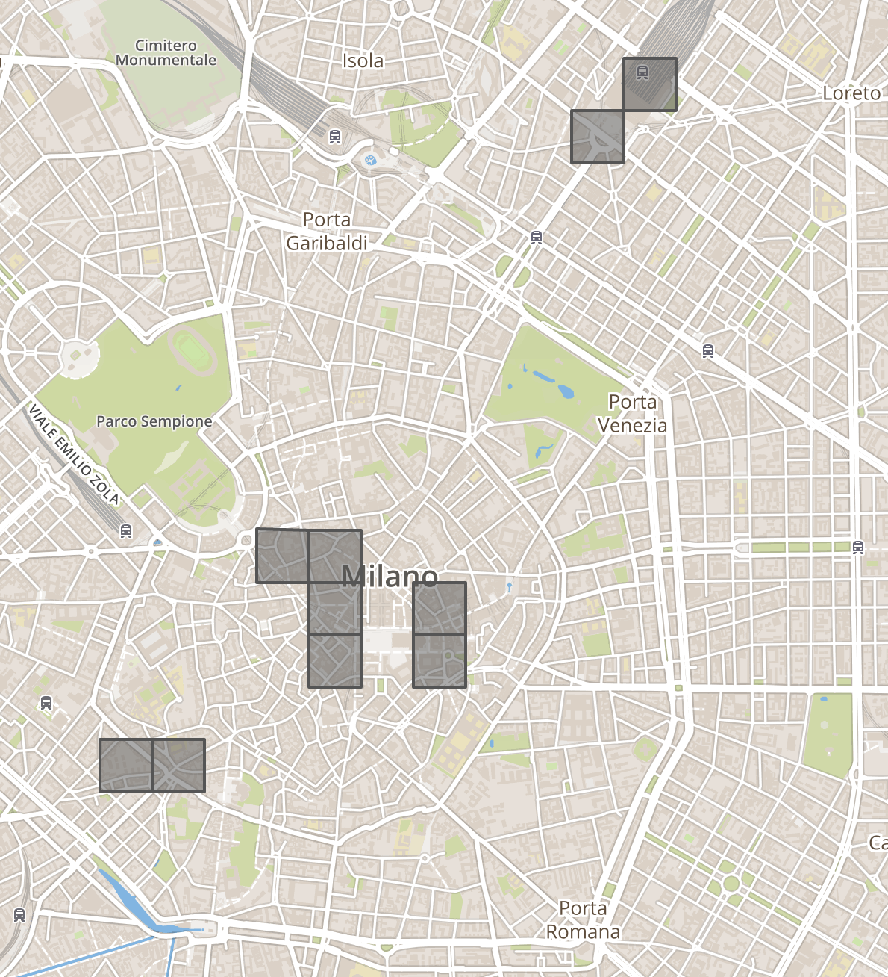

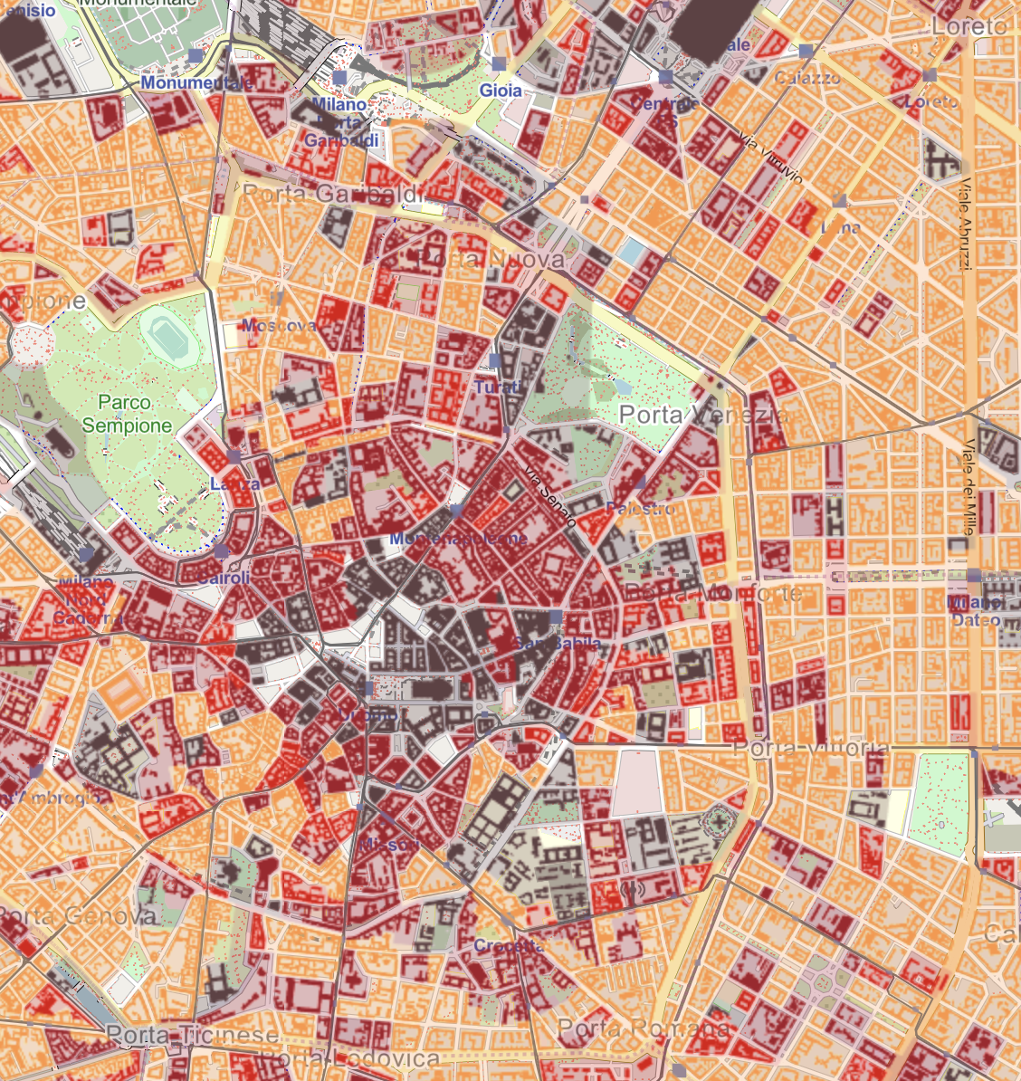 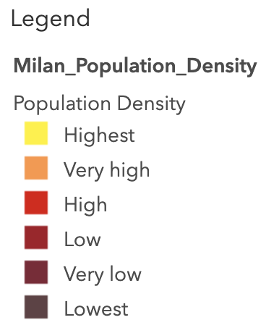

## Comparison of telecommunication activities in Grids 5059 & 5161

We will now compare the SMS In/Out, Call In/Out volumes in grid 5059 and Internet activity volumes in grid 5161. Stacked area plot shows that grid 5059 receives more SMS volumes than Calls.

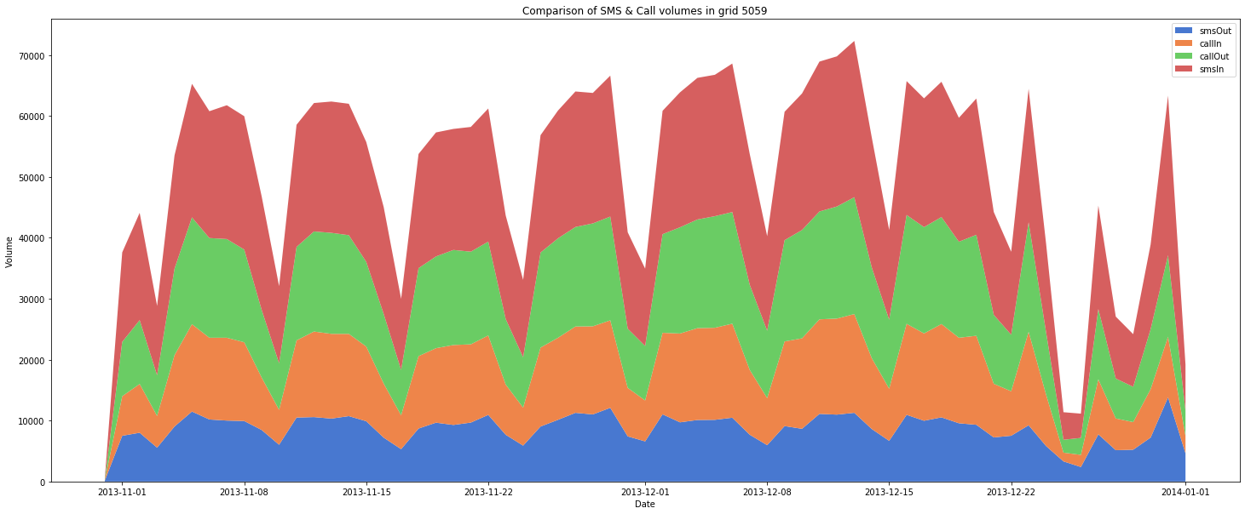

Time series plots at daily level shows weekly seasonality. And there is a sudden drop in all activities around Christmas holiday, Dec 25th 2013, shown in the red shaded region and a steep increase in calls and SMS volume around New Year Eve. Internet activity volumes in grid 5161 also shows weekly seasonality, and a sudden drop around Christmas holiday and New Year.

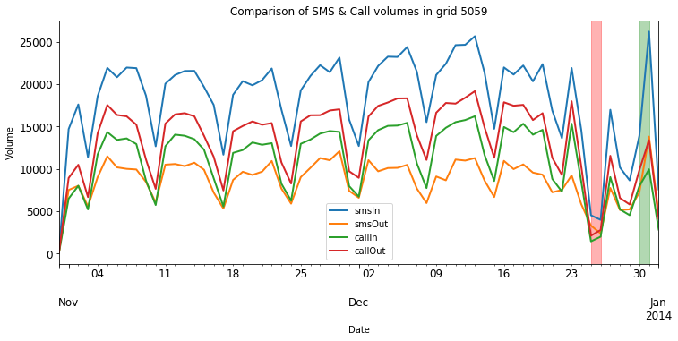

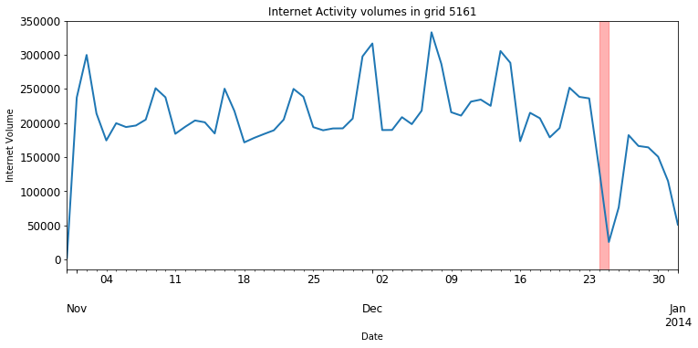

## Understanding the seasonality

### Box plot:

Box plot helps us understand the seasonality in the time series plots we observed earlier. We see that SMS and call volumes decreases during weekends while Internet activity volumes increases during weekends.

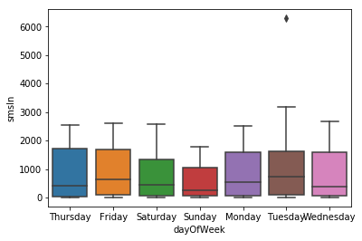 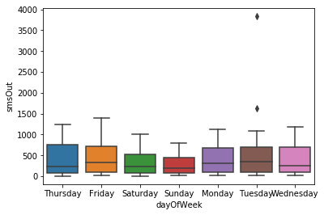

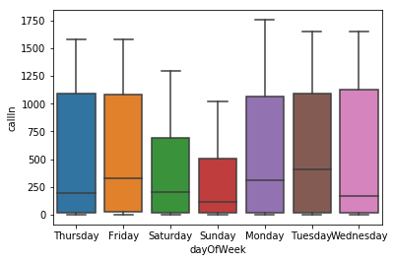 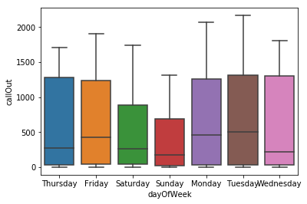

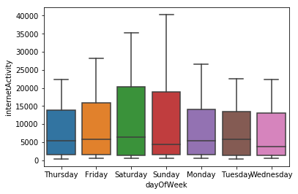

### Heat map:

On weekdays, SMS and call activities typically starts around 6am, and internet activity starts around 9am. While on weekends, all activities starts around 8am. Internet activity on Saturdays extends late into the evening, until 10pm. As observed in box plots & heat maps, there is a decrease in SMS & Call volumes and increase in Internet activity volumes during weekends.

